|  |  |
| --- | --- |
|  | |
| National Park Service  U.S. Department of the Interior  Natural Resource Stewardship and Science | National Park Service Logo |

Natural Resource Condition Assessment Development Guide Version 1.1

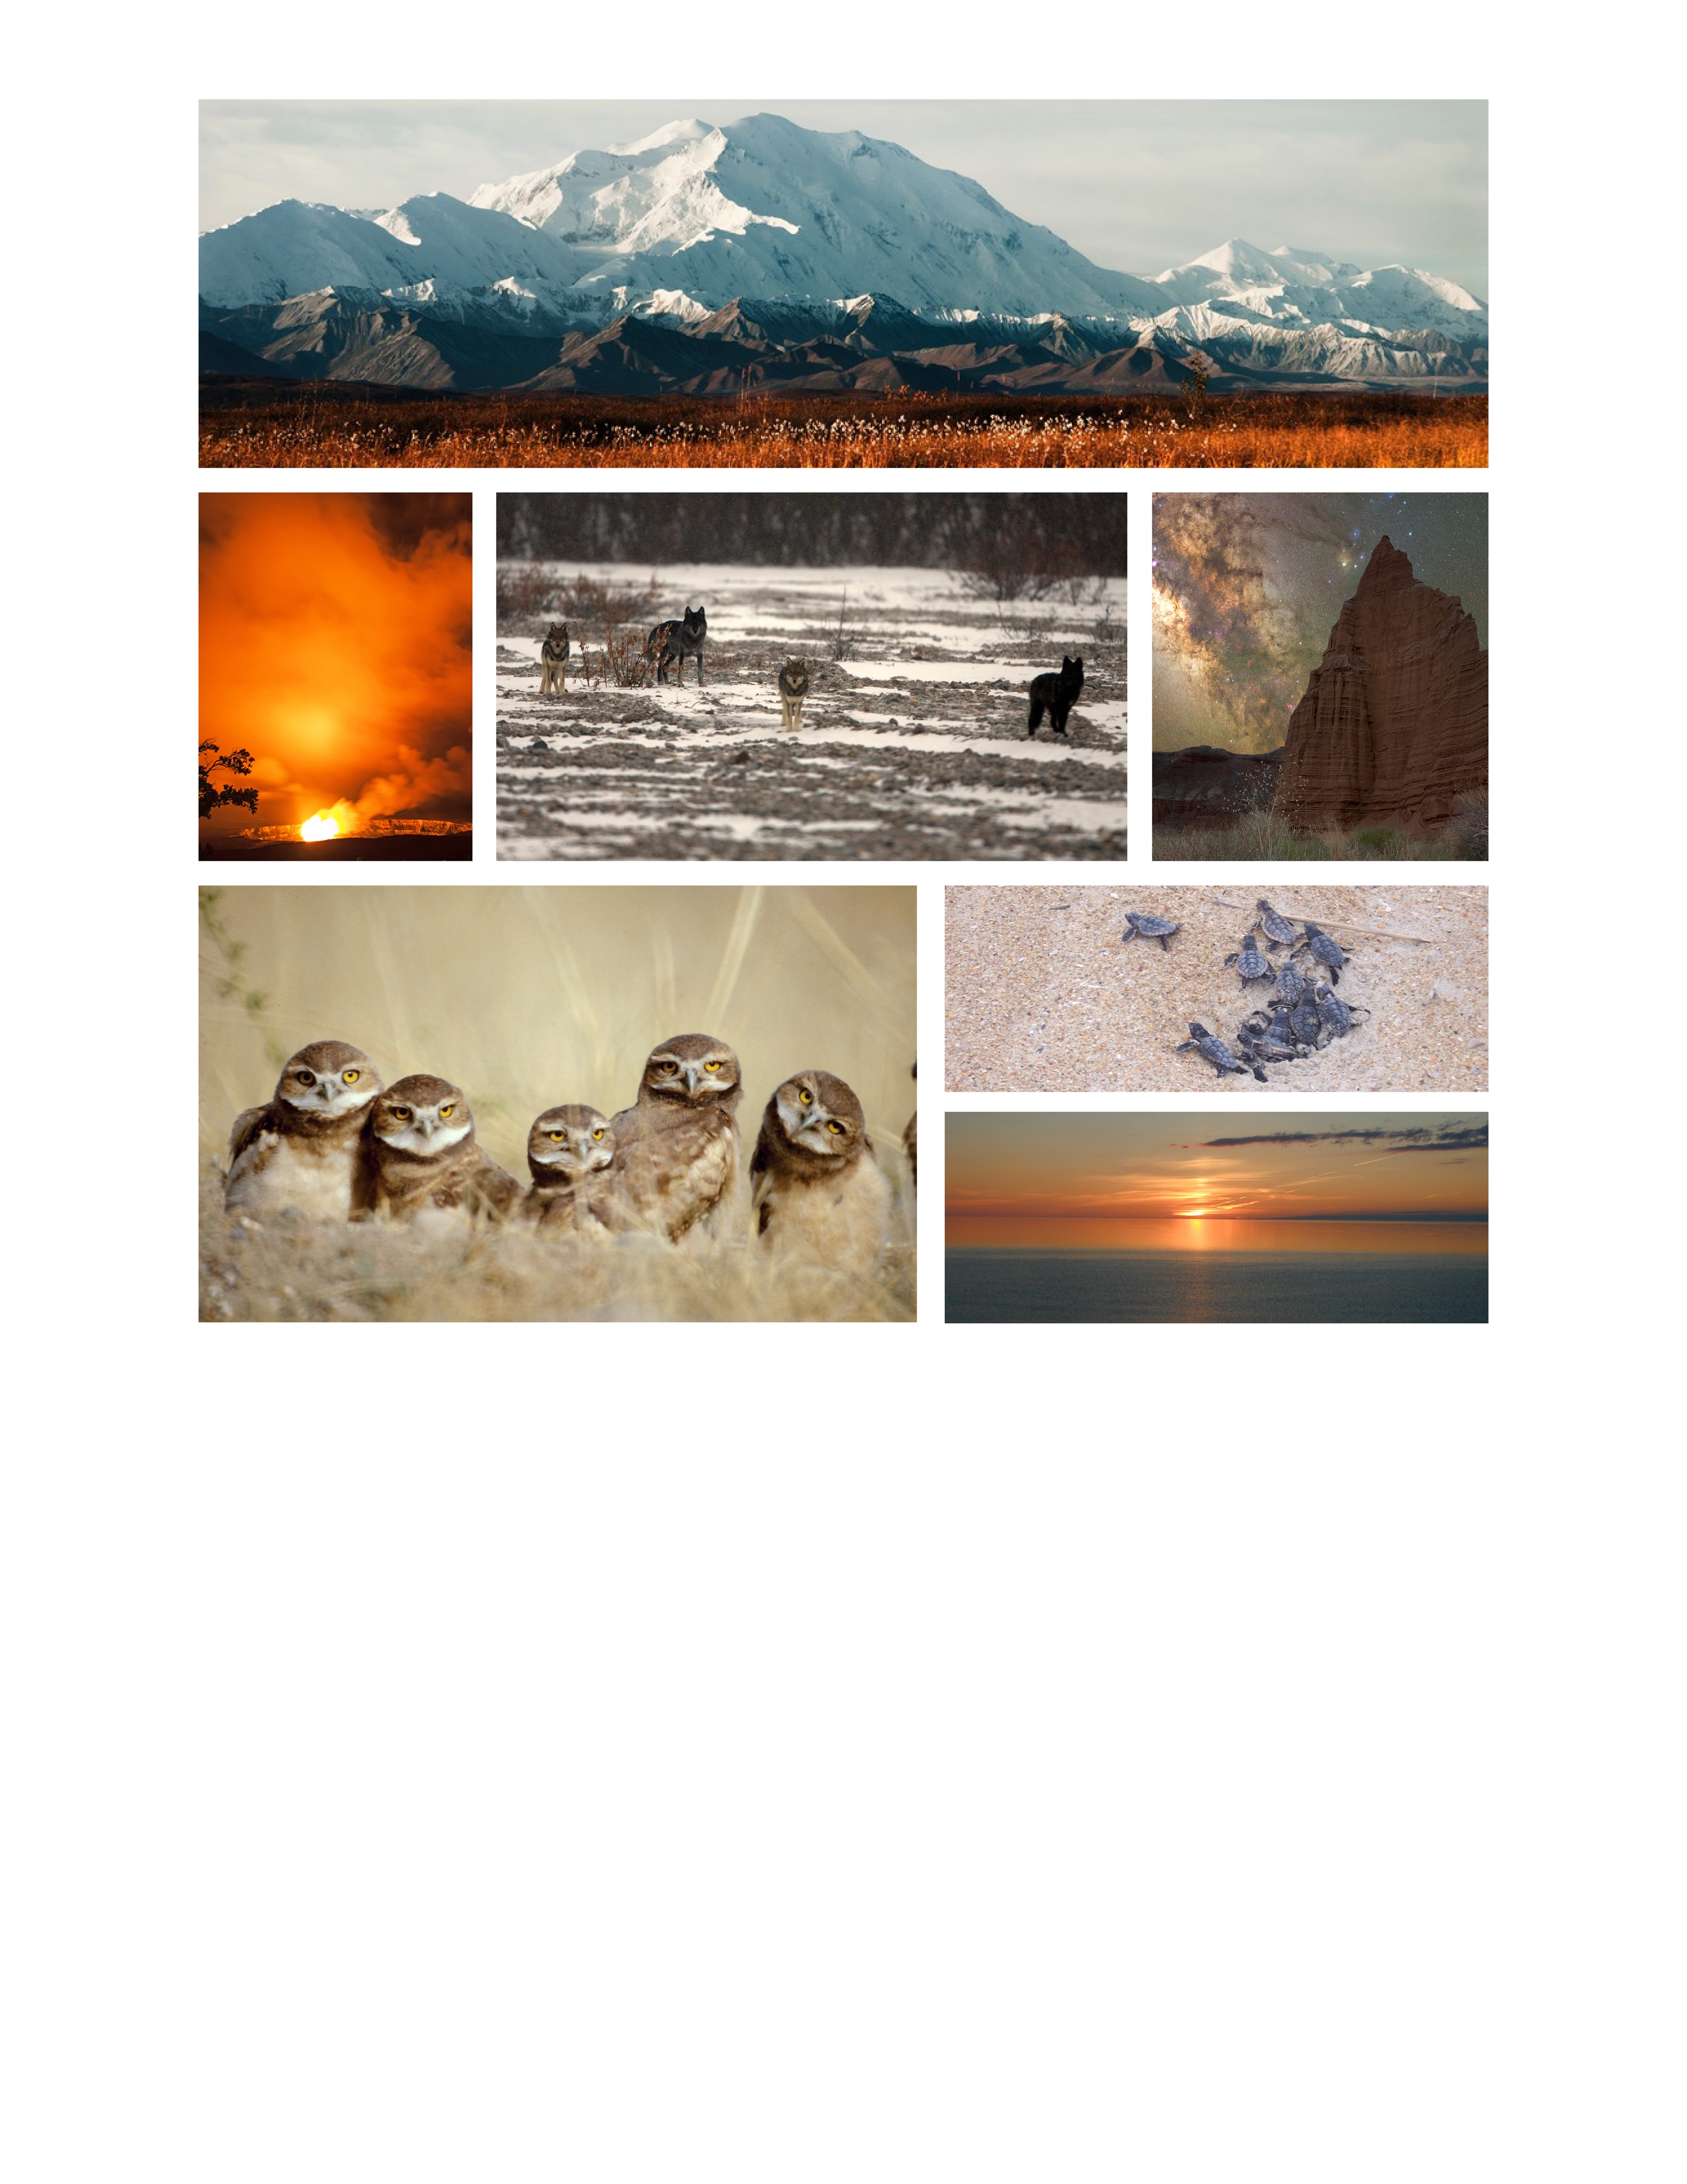

**ON THE COVER**

Top: Denali National Park and Preserve in the fall. Image Credit: NPS / TIM RAINS.

Middle (left to right): Halemaʻumaʻu lava lake glow in Hawaii Volcanoes National Park. Image Credit: NPS / J.WEI. 7-mile wolf pack. Image Credit: NPS. Milky Way at Capitol Reef National Park’s Temple of the Moon. Image Credit: NPS / PHIL SISTO.

Bottom (left to right): Burrowing owls. Image Credit: NPS / ROB BENNETTS. Loggerhead sea turtle hatchlings in Cape Hatteras National Seashore. Image Credit: NPS. Lake Superior sunset at Pictured Rocks National Lakeshore. Image Credit: NPS / KIM STRUTHERS.

Contents

Page

Appendices iii

Executive Summary v

Acknowledgments vi

Glossary viii

Chapter 1. Introduction 1

NRCA Goals 1

Technical Report (Product) 1

Workflow (Process) 2

Roles & Responsibilities 3

Chapter 2. Project Initiation 4

Chapter 3. Scoping Workshop 6

Chapter 4. Study Plan Development & Review 10

Chapter 5. Technical Report Development & Review 13

Chapter 6. Project Finalization 19

Literature Cited 21

Appendices

Page

Appendix A. NRCA Project Workflow 23

Appendix B. NRCA Developer Materials Packet Summary 25

Appendix C. Literature Organization 27

Appendix D. Unincorporated Review Comments Tracking Form 28

Executive Summary

For 20 years, the National Park Service (NPS) [Natural Resource Condition Assessment (NRCA) Program](https://www.nps.gov/subjects/science/nrca.htm) has provided information on natural resource conditions and trends to park managers. Now, after publishing 225 NRCA reports, the program has developed a fresh NRCA approach to deliver a more efficient (faster) workflow process and succinct report to park managers to use in their decision-making activities. This guidance document conveys the new NRCA process and product.

NRCA projects are completed in one year, and reported in a published, ~50-pages or fewer technical report. Every NRCA report is organized using a drivers, pressures, stressors, states, and responses (DPSSR) logic framework to identify the most important information to include on conditions and trends for park-selected natural resources. The technical report and supporting materials, such as GIS datasets, are posted to the [NPS Data Store](https://irma.nps.gov/DataStore/Collection/Profile/7765), with each park’s approval of the publicly shared content.

The new NRCA workflow (ES-1) leverages the previous NRCA’s keys to success. NRCA Program staff provide direct oversight and project facilitation for every NRCA project, ensuring active engagement of key team members throughout an NRCA’s life cycle. Expectations and roles of all team members are clearly defined at the outset of every project and a multi-disciplinary scoping workshop, including park staff, subject matter experts, and NRCA Program staff, is held to discuss the park managers’ topics of interest and identify key sources of information. A study plan is developed, summarizing the information discussed during the scoping workshop and outlining the condition assessment methodologies. The plan is reviewed by park managers *prior to* drafting content for the NRCA technical report. Sections of the technical report are then drafted, and the results are reviewed by park staff, subject matter experts, and NRCA Program staff to ensure the reliability of the reported findings.

Figure ES-1. Every NRCA project uses a standard workflow that occurs over one year from scoping to report development. Project milestones are shown in the bottom row.

After each NRCA project is completed, the following files are publicly shared.

* Study plan
* Technical report published in the NPS Natural Resource Report series
* Ancillary files (e.g., Excel data, GIS data, species checklists, analysis summaries)

Acknowledgments

Since the NPS NRCA Program’s inception in 2003, NPS managers and scientists, including partner scientists, have shared their vision and commitment to providing national park managers with natural resource condition-related information via NRCA projects. At the outset, without the vision of the NPS leadership who ushered in the Natural Resource Challenge—a science-based program to manage and protect the natural resources in national parks—the NRCA Program would not have formed. The leadership knew that “understanding complex systems was key to managing them for long-term preservation” and that programs for conveying such science and long-term knowledge were necessary. In addition, the local resource knowledge and scientific research that NPS managers at the park, regional, and national levels contributed to NRCAs have been invaluable to the success of the program and its ability to deliver reliable resource condition information to park managers. And finally, thank you to our university partners for your contributions; many of the lessons learned and shared in this development guide reflect your insights. We thank each of you.

Glossary

**Condition Assessment**: A condition assessment reports on the current condition of one or more *indicators* *of condition* for a focal natural resource when enough data are available. What constitutes “enough” data is a professional judgement based on a review of all available data and conceptual models and discussions with park staff, subject matter experts, and researchers involved in collecting the applicable data. Indicators of condition are rated using a three- or five-level rating system, ranging between good-fair-poor; if trend can be reported for a measure, it is reported as improving, stable, deteriorating, or unknown/indeterminate.

**Condition Evaluation**: A condition evaluation is either a condition assessment or a gap analysis. Which one depends on the amount of data with which to evaluate conditions and assign a condition rating(s). If enough data are available for key indicators of condition, then a condition assessment is developed. If data are lacking, a gap analysis is developed.

**Condition Rating Statements**: These correspond to the three- or five-level rating system developed to evaluate the indicators of condition. The five-level rating scheme includes good, good/fair, fair, fair/poor, and poor, and the three-level rating scheme includes good, fair, and poor, with corresponding “stop light” colors. Condition ratings statements are developed at the indicator level for the combination of measures evaluated for each indicator of condition. The condition rating statements reference criteria must be logical and defensible based on the best available science.

**Confidence Level**: These correspond to a three-level rating system of low–medium–high described for the indicators of condition ratings. The levels are based on the repeatability of evaluation findings and how confident the author is in the information used to rate condition.

**Current Condition**: This defines the status of condition for an indicator based on the evaluation of one or more measures. “Current” applies to the condition as it exists today based on what has previously occurred, not on what is likely to occur. For example, something such as hazard level or risk, which identifies the proposed or likelihood of what may occur because of the intrinsic characteristics of the resource, will not be used to report on current condition**.** In general, data collected within the last ten years can be used to determine current condition, although this will depend on the rate of change for a particular indicator of condition and its corresponding measures.

**Data Gap**: A data gap is when information is lacking, whether in the form of unavailable literature or subject matter expertise to adequately evaluate conditions.

**Driver**: Ecosystem drivers are major (and most often) external influencers of change to natural systems, functioning across extensive areas or scales. Drivers are defined as “any relatively discrete events in space and time that disrupt ecosystem, community, or population structure and change resources, substrate, or the physical environment (White and Pickett 1985).” Drivers are most often beyond a manager’s ability to influence or change.

**Gap Analysis**: A gap analysis summarizes what is known about a focal natural resource, in addition to highlighting critical information that is lacking. A gap analysis does not rate indicators of condition. Instead, a table of *proposed* indicators, measures, and reference criteria are reported, with the goal of providing a framework for a future study.

**Indicator of Condition**: An indicator of condition (or simply indicator) is a descriptor of something useful to measure, but it is not the measure itself. Indicators consist of one or more measures. Condition ratings are assigned at the indicator level. This is because natural resources are often more complex and nuanced than what is reflected in just a few measures and associated indicators.

**Measure**: A measure is qualitative, quantitative, or a combination of both and provides specific information about the indicator of condition. There can be one or more measure(s) for each indicator. Selected indicators and measures are often those that are commonly used by NPS staff in monitoring the status of a resource, as well as those that are well represented in the literature and can provide context when park-specific data are lacking.

**Pressure:** A pressure results from a driver**,** potentially affecting a resource. An NRCA presents drivers and pressures as the fundamental forces that play important roles in regulating or altering ecological resource conditions in the park. NRCAs do not differentiate between drivers and pressures because the focus of the report content is on the manifestation of those influences on natural resource conditions, not on the differentiation of drivers and pressures.

**Reference Criteria**: Reference criteria are pivot points, thresholds, or ranges based on peer-reviewed literature, state standards, known criteria, or some other justifiable source of information that forms the basis of the condition rating statements. Quantitative reference criteria are generally better than qualitative reference criteria, but when specific data are lacking, qualitative reference criteria are useful. Regardless of the type of reference criteria used, they must be justifiable and cited appropriately for the repeatability of future condition evaluations.

**Response:** Useful near-term actions/activities park managers can consider for protecting, maintaining, and/or restoring important ecological resource conditions in parks.

**State (Condition):** The current “health” or condition of the focal natural resource reported at the indicator of condition level. State is synonymous with condition.

**Stressor**: “Stressors can manifest as physical, chemical, or biological perturbations [disturbances] to a system that are either foreign to that system, or natural to the system, but occurring at an excessive or deficient level. Stressors cause significant changes in the ecological components, patterns, and processes in natural systems. They act together with drivers on ecosystem attributes (Barrett et al. 1976).” When possible, stressors are selected as measures with which to evaluate the current condition of an indicator.

**Trend**: A trend is a statistical analysis intended to find patterns in data. If a trend can be reported for a measure, it is reported as improving, stable, deteriorating, or unknown/indeterminate. Only quantitative trends are reported in the NRCA technical reports.

Chapter 1. Introduction

The National Park Service (NPS) Natural Resource Stewardship and Science Directorate provides scientific, technical, and administrative support to national parks for the management of natural resources. The directorate includes nine Service-wide divisions that assist NPS managers across the United States with protecting park resources and values sustainably over time. The NPS Natural Resource Condition Assessment (NRCA) Program is within the Service-wide’s Water Resources Division.

The NRCA Program’s mission is to assess and report the conditions and trends of natural resources to park managers. Throughout the program’s 20-year history, valuable lessons in the NRCA development (process) and reporting (content) have been learned. In 2020 and 2021, the NRCA Program applied those lessons and piloted a fresh approach to developing and reporting NRCAs to deliver a more efficient (faster) and shorter NRCA technical report to parks. **This guidance document conveys the new NRCA workflow process and reporting product, primarily for those who are developing NRCA projects.**

NRCA Goals

The primary goal of an NRCA is to deliver scientifically credible natural resource condition and trend information for park manager-selected topics of interest. NRCAs distill existing information into concise, easily understood assessments that inform management decisions. NRCAs also highlight data gaps to help managers prioritize information that is needed to inform future management decisions.

Each NRCA project is completed within one year from the scoping workshop to the development of the technical report, using a standard workflow. The NRCA findings are published in a technical report (Chapters 1–4 are ~50 pages or fewer), which is posted to the NPS Data Store, along with supporting materials (e.g., GIS datasets, study plan, assessment methods summaries).

Technical Report (Product)

The content of every NRCA report is organized using an ecological drivers, pressures, stressors, states, and responses (DPSSR) logic framework (Figure 1; adapted from the Office of National Marine Sanctuaries 2020; Harwell et al. 2019). The DPSSR framework emphasizes the connection between the natural and human (or anthropogenic) drivers-pressures (hereafter referred to as drivers) that influence ecosystem or natural resource change. A change may affect the condition (or state) of a resource as a positive or negative stressor. Park managers may respond to a stressor(s) that negatively impacts a resource to restore its condition to a desired state, such as controlling non-native invasive plants in a high priority habitat.

Even though there are stressors that managers can’t directly influence, it’s still helpful to understand the potential resource impacts, especially when setting realistic resource management goals. The DPSSR framework helps to illuminate these connections between drivers, stressors, resource conditions (states), and management responses, and guides the selection of the most relevant NRCA content to report.

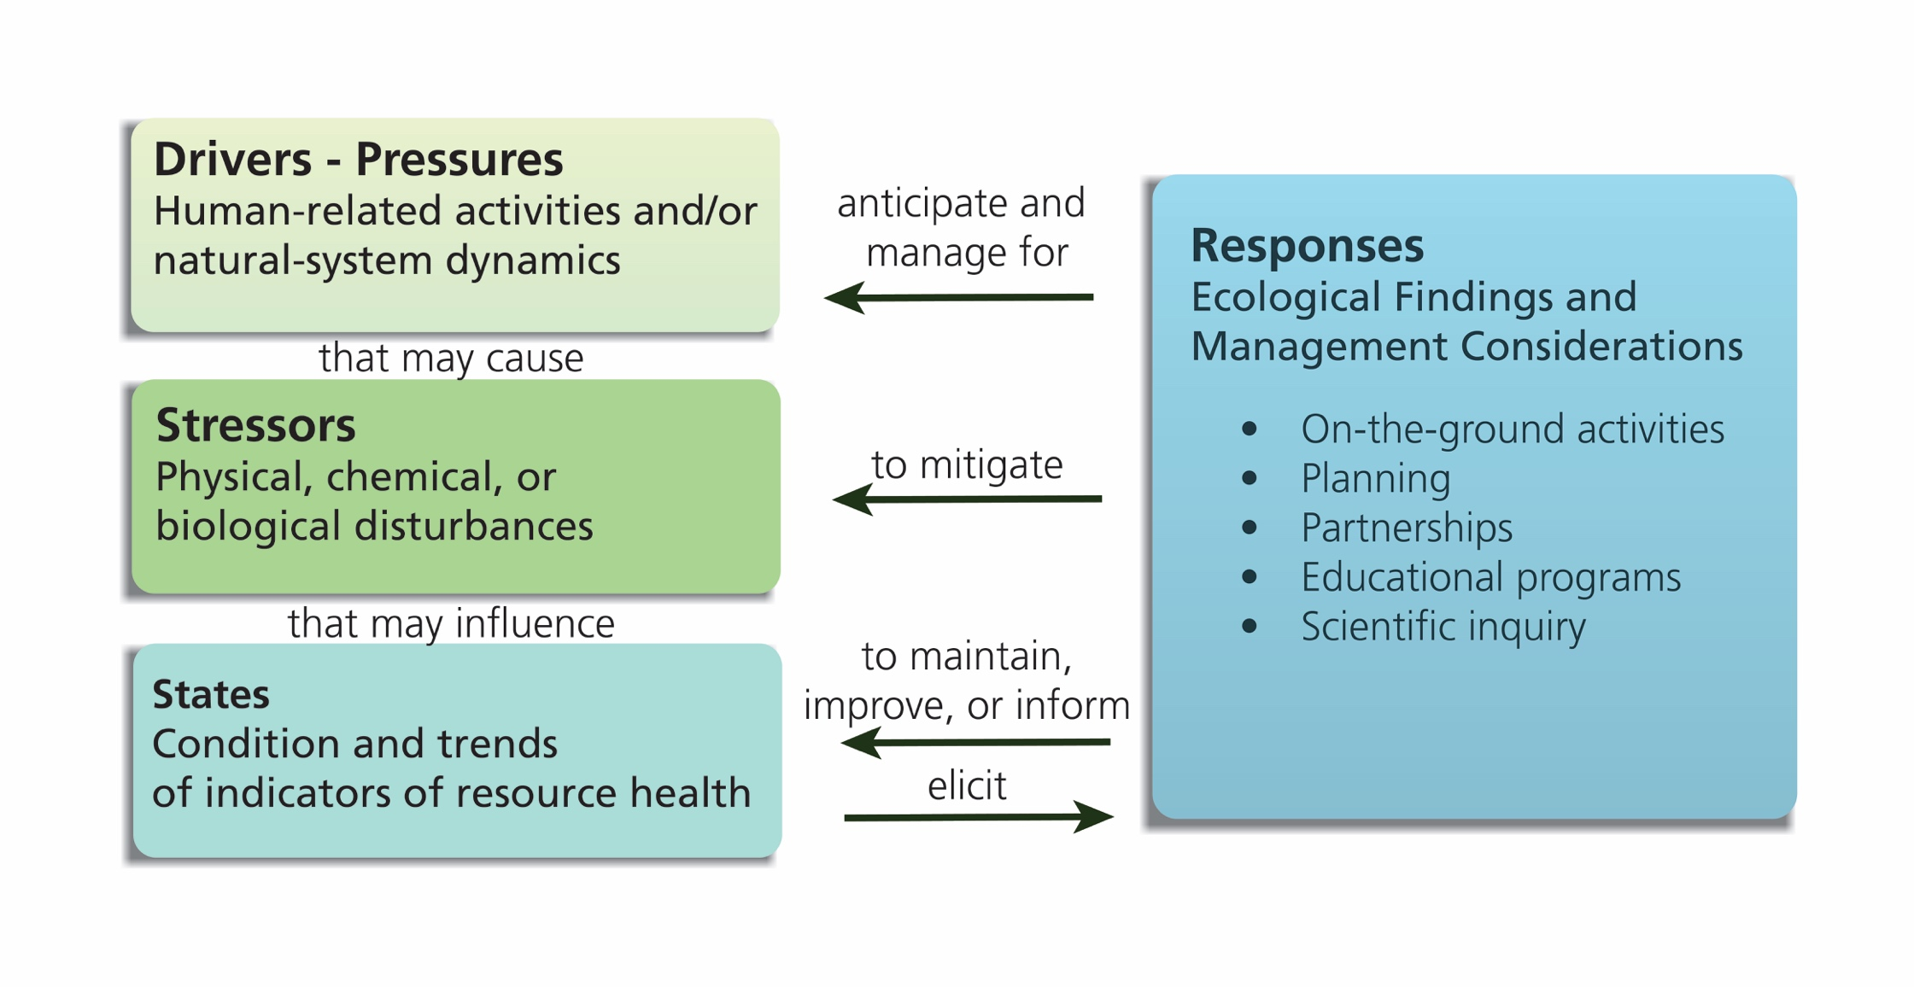

**Figure 1.** The drivers, pressures, stressors, states, responses (DPSSR) logic framework used to organize NRCA report content (adapted from Harwell et al. (2019) and the Office of National Marine Sanctuaries (2020)).

It’s important to note that while an NRCA project does not report on conditions for all the natural resources at a park, the DPSSR framework can guide the evaluation of additional natural resource conditions in the future. This is especially important as drivers or stressors change or as new information becomes available with which to evaluate natural resource conditions.

Workflow (Process)

To ensure NRCA projects are completed in a timely manner, a standard workflow is used (Figure 2). And while each NRCA is developed similarly, there remains flexibility within the workflow process to adapt to each park’s unique circumstances, which will be evaluated on an ‘as needed’ basis.

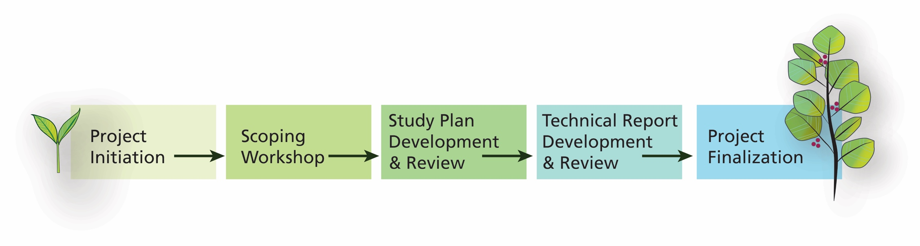

**Figure 2.** An NRCA workflow occurs over one year from the scoping workshop to the report development and follows a standard development process.

Appendix A summarizes the NRCA workflow by the development phases, team members, and key milestones. Chapters 2–6 of this guide describe each of the NRCA development phases shown in Figure 2 ­­­and their associated purpose, development methods, and standard report content. More details are provided in the project templates that are posted on the [NRCA Program’s website](https://www.nps.gov/subjects/science/nrcaguide.htm).

Roles & Responsibilities

Publishing a peer-reviewed report quickly requires a well-defined workflow. To achieve this goal, the NRCA Program clarifies the primary roles and responsibilities of each NRCA project team early in the development process, which is summarized below.

**Washington (WASO) NRCA Program Staff:** The NRCA Program staff provide direct oversight of each NRCA project. Program staff facilitate or co-facilitate each project by defining the scope of the NRCA, creating organizational structure, identifying and enlisting team members early in the project development process, and providing standard NRCA materials (refer to Appendix B), such as meeting packets and study plan and report templates to NRCA authors (e.g., principal investigator). Program staff also serve as peer-review coordinators and initiate and finalize each NRCA project.

Note: NRCAs may be developed by program staff, by an external principal investigator, or by using a combination of the two. For example, technical analyses may be required for one or two focal resources, which can be outsourced. If external assistance is needed, NRCA Program staff will provide the administrative oversight (e.g., develop agreement or contract, establish funding account, distribute the awarded funds).

**Regional NRCA Coordinators:** NRCARegional coordinators panel and select parks’ NRCA project proposals for funding in their respective regions. A coordinator may assist with NRCA project facilitation and/or development when needed, but the intention of the new NRCA process is to centralize the project oversight at the program level. However, responsibilities for regional NRCA coordinators may be identified as each project’s scope is defined.

**Park Managers:** Park managers identify key team members; select the natural resource topics of interest; and identify the park’s information needs. They provide unpublished park data and reports and review the study plan and technical report drafts as they are developed. They also flag sensitive information to ensure it is not publicly shared before the project is finalized and posted on the web.

**Subject Matter Experts (hereafter SMEs):** SMEs are enlisted as members of the team based on the park’s topics of interest. SMEs can be from local, state, or national agencies and/or individuals. Each SME’s role varies depending on the project need, ranging from scoping workshop participation, providing data or reports, drafting report sections, and/or reviewing drafts of their subject matter expertise. Most SMEs volunteer their time without financial compensation unless they are asked to draft a section of the report and/or to provide in-depth analysis for a focal resource topic. If SMEs are financially compensated, the NRCA Program staff will develop and administer any funding agreements as necessary.

**Principal Investigator (hereafter PI):** If a PI is funded to develop an NRCA project, s/he will assume the roles and responsibilities of the primary facilitator, beginning with the Scoping Workshop phase. The PI will also serve as the primary report author. NRCA Program staff will meet with each PI after funds have been awarded to plan the project (e.g., clarify expectations and timeline, share materials).

Chapter 2. Project Initiation

**The purpose of the project initiation phase is to further understand the park’s natural resources of interest and management needs identified in the funded NRCA project proposal. This is accomplished via a one-hour virtual meeting with the park and NRCA Program staffs.**

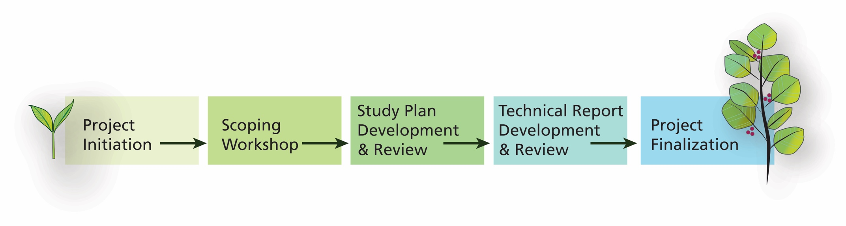The workflow of the project initiation phase is implemented by the NRCA Program staff and begins with contacting the park that was awarded NRCA project funding via the annual NRCA Project Proposal Call. A one-hour virtual meeting between program and park staffs will be held to: (1) present an NRCA overview, and (2) discuss park needs and resources of interest.

The NRCA Program staff will summarize the one-hour meeting discussion and begin defining the scope of the NRCA project and create organizational structure.

1. **List Preliminary Topics of Interest:** The NRCA Program staff will compile an initial list of natural resources and drivers/stressors of interest identified by park staff, including their management questions and needs.
2. **Assemble Project Team:** The NRCA Program staff will develop any agreements for technical assistance and award funding and will inquire with SMEs to begin assembling data and reports and/or plan for future participation (e.g., attend scoping workshop, draft a section of the report, analyze data, or serve as a peer reviewer).
3. **Gather Information:** All materials, including any initial data and reports that have been received, will be assembled into a project packet, along with this guidance document, a study plan template and example, and a technical report template, with a link to a published example.
4. **Award Funds & Share Materials:** If a PI is selected to develop an NRCA, the NRCA Program staff and PI will meet virtually. The meeting objectives will include a review of the project packet and templates, a discussion of the project’s workflow, timeline, and milestones, and to initially plan for the scoping workshop.

For all involved team members, especially NRCA developers (e.g., PI), it’s important to recognize that park staff are not responsible for the NRCA project development. While every NRCA project benefits from a park’s involvement, it’s equally important that developers are organized and comprehensive in their information requests of park staff. Park staff are not expected to provide information sources to developers that are located outside the park. Information that can be obtained through the web or by contacting an individual or agency directly is the developer’s responsibility. In addition, the park’s primary responsibility is to review drafted sections, not to draft the content. If a park staff member wants to contribute directly to the content, that is acceptable, but it should not be solicited of the park. Throughout every NRCA project’s life cycle, it’s very important to minimize the amount of work asked of park staff. The NRCA Program staff will help facilitate each project’s development process to ensure that what is required of the park remains at a minimum while maintaining an appropriate level of engagement throughout the project’s entirety.

Chapter 3. Scoping Workshop

**The purpose of the scoping workshop phase is to identify and prioritize the set of natural resources and drivers-stressors to emphasize in the NRCA project via a multi-disciplinary discussion. This is accomplished through a 1–2-day project team hybrid meeting.**

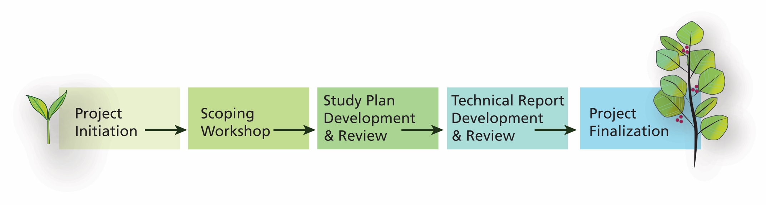The scoping workshop workflow includes (1) workshop planning, (2) initial literature review / data gathering, and (3) workshop facilitation.

## Workshop Planning

The majority of the scoping workshop phase is dedicated to planning the actual workshop. Identifying the participants, contacting them, and working through the meeting logistics require as much lead time as possible. To manage for time, the NRCA Program staff provides pre-developed scoping workshop files in the materials packet, which can be customized for each park’s workshop.

### Workshop Logistics

Workshops are held as hybrid meetings—virtual and in-person (barring any stay-at-home orders). The NRCA Program can provide the technology (e.g., camera and microphone) for the virtual logistics of the meeting if needed, and the PI will lead and facilitate both the in-person and virtual workshop. A virtual meeting link that includes a conference bridge line supporting a captioning service for hearing-impaired participants should be provided. The NRCA Program has Microsoft Teams accounts with the conference bridge line capability if needed. Please allow some lead time for the hearing-impaired participants to contact a captioner who can co-attend the virtual meeting *before* the invitation is sent. We highly recommend testing all the equipment, connections, and performing a trial run of the presentations the day before the meeting. Setting up the in-person meeting space should also be completed the day prior to the start of the workshop.

The workshop agenda includes meeting date, time, location, including the physical address, list of participants, meeting objectives, and agenda sessions (i.e., times, topics, participant discussion panels). The less obvious agenda details include lunch arrangements, such as letting in-person participants know whether they should bring their lunch and whether a refrigerator and/or microwave are available for their use. Or letting participants know if they can pick-up lunch (break is between ½–1 hour) and return to resume the workshop on time. Also, park protocols for Covid-19 or other unforeseen issues need to be considered and conveyed to participants prior to the workshop.

Workshop discussion sessions should be grouped by similar topics, and the length of each session will depend on the complexity of the topic and the number of participants. Also, the order of the sessions may be determined by participant schedules (e.g., a participant can only attend during the first half of the meeting but is needed as a subject matter expert for two or more sessions). Inquiring with the park about lodging and flight options is helpful, both for your own personal travel arrangements and for any participants who may need this information for their planning purposes.

### Workshop Participants

The NRCA Program staff, PI, and park managers will work together to identify the scoping workshop date and participants, including subject matter experts, based on the park’s resource topics of interest and questions. Inquiring about participant availability can be accomplished via a ‘Save the Date’ group message or via individual inquiries.

There are trade-offs between being more inclusive versus effective for project scoping and inviting too many participants. Including participants who are more broadly familiar with a park’s resources and issues can help others think about the broader, bigger picture questions and systems. It’s important to not overly focus on topics of interest during the scoping workshop unless there’s a compelling reason to do so, which can be determined on a case-by-case basis.

### Workshop Roles

Workshop facilitator, presenters, technology trouble-shooter, monitor of virtual participants, and note taker roles need to be defined. Two examples of the scoping workshop role guidance are provided in the materials packet for reference and use.

### Workshop Invitation Packet

Based on the NRCA Program’s 2022 scoping workshop evaluation feedback, participants asked that a summary of park information be sent with the workshop invitation email. The information can include how the park is administered (e.g., as a partner park), staffing, and a general overview of the resources. This information may need to be briefly summarized at the beginning of each of the workshop’s sessions because of the potential change of participants. Each scoping workshop’s needs will be slightly different and should be planned for accordingly.

## Initial Literature Review / Data Gathering

To prepare for the workshop, the PI will review the project initiation call notes to (1) become as familiar as possible with the natural resource topics of park management interest, (2) identify and gather potentially useful data and reports related to the topics and resources of interest, (3) create scoping workshop session topic slides to prompt discussions (examples are provided in the materials packet), and (4) develop questions/notes for the scoping workshop discussions.

The following is a list of suggested sources to consult during the initial literature search but is not exhaustive:

* NPS management plans and foundation documents (especially) serve as excellent guides to understanding resources and issues at a park.
* [NPS IRMA](https://irma.nps.gov/Portal) (Integrated Resource Management Applications) website includes reports and datasets for natural resources in parks. This site also includes older reports, which serve as good background sources and some GIS data for parks.
* The [Research Permit and Reporting System](https://irma.nps.gov/RPRS/) portion of IRMA includes information on current research activities in the park. You do not need to login; simply click on the “Search” button at the top of the page and select “Investigator Annual Reports.” A follow-up with the particular researcher is often required to obtain the most recent and comprehensive data, although some investigators include detailed annual reports as attachments.
* [NPS Inventory and Monitoring Network](https://www.nps.gov/im/index.htm) (I&M) and the park’s websites are also excellent sources of information for park research activities, even if the park isn’t an I&M park. The networks often have some of the most current and applicable data. Each I&M’s vital signs reports provide conceptual models, which help identify the appropriate selection of indicators of condition, measures, and primary drivers and stressors for natural resources.
* Peer-reviewed papers and published theses/dissertations for research conducted in a park (e.g., Google Scholar search).

The U.S. Geological Survey, U.S. Forest Service, U.S. Fish and Wildlife Service, and state natural resource divisions are also good sources of information for evaluating conditions of park resources. Other sources will depend on the specific topics and resources that will be emphasized in a given NRCA. In addition, parks often have reports and data that are not posted on the web but are valuable to the NRCA development process. **Gathering the park-housed information usually requires some lead time, so it’s important to prioritize this task to ensure timely project completion.**

The PI can begin developing the study plan and list any needed data and reports that are not available online based of the initial literature review. In addition, the PI will need to develop a literature organization system and maintain it throughout the project’s entirety (guidance is provided in Appendix C). All relevant literature that is gathered for the NRCA will be packaged and submitted to the park during the project finalization phase. The literature provides the supporting documentation necessary for understanding how the study plan and technical report evaluations were developed and supports study transparency, which is key to future repeatability of evaluating resource conditions and trends.

### Pre-workshop Virtual Meeting (optional)

A two hours or less pre-scoping workshop virtual meeting may be necessary, depending on the complexity of the park’s natural resources and associated drivers and stressors and PI questions. The purpose of the meeting is to inquire about additional data or reports and to clarify questions about any datasets or reports already reviewed. It also ‘sets the stage’ for a productive scoping workshop by becoming more familiar with the information to ask more in-depth questions during the workshop discussions.

## Workshop Facilitation

The scoping workshop is a 1–2 day virtual and in-person (hybrid) meeting. It’s a facilitated discussion of the natural resources of park management interest and their associated drivers and stressors among participants. The primary objectives of the scoping workshop are to identify the data and reports that pertain to the resource topics of interest; identify additional experts or points of contact; clarify manager questions and needs; and select the resource topics to emphasize in the NRCA report. Park staff provide a park tour for the NRCA Program staff and PI, usually the day prior to the workshop.

### Scoping Workshop

The scoping workshop begins with a welcome and an overview of the agenda, followed by very brief participant introductions. The NRCA Program staff provide an overview of the program and of the park’s NRCA development timeline and deliverables. The PI will then describe the workshop objectives and discussion approach. A brief introduction of the park’s resources, setting, and staffing will be provided by the park managers and/or the I&M staff if the latter take part in the workshop.

The on-site meeting provides an opportunity to gather data, reports, and photos of park resources (including photo permissions, which are required before the technical report can be published), in addition to seeing the resources and management issues of concern; however, time priority should be given to the review and discussion of the resources of interest (vs. data gathering or a tour). If the team is attending a virtual meeting only, we recommend that it occurs over the course of two days, scheduled over two weeks. This allows time for the PI to gather and review any new data or information discussed during the meeting’s first day for the second meeting day’s review and discussion.

### Post-workshop Follow-up

The outcomes of the scoping workshop phase are to identify a park’s selected resources of interest; associated key condition-related questions and/or information needs; drivers and stressors; and condition evaluation details for selected resources, which will include the level of evaluation, referenced ecological conceptual model(s), indicators of condition, measures, reference criteria, and condition rating statements. Collectively, this body of information forms the basis of the park’s NRCA study plan. A workshop evaluation will be sent to participants, ideally within the same week as the workshop. An example list of questions, developed in Microsoft Forms, is provided.

Chapter 4. Study Plan Development & Review

**The primary goal of the study plan development & review phase is to provide a “proof of concept” document for park managers to review prior to drafting content for the NRCA technical report. The park-reviewed study plan serves as an informal agreement between the park and the PI, outlining the condition evaluation approaches and the datasets that will be used for the analyses and reporting.**



Key aspects to a successful NRCA project are managing project scope and obtaining the data and reports that will be used for analyses prior to drafting the NRCA report content. The scope of an NRCA will be outlined in the study plan and any needed data and reports should be requested during this phase of the NRCA development process. If data or reports cannot be obtained prior to drafting the relevant sections, they may be omitted from the technical report. It’s very important that the PI inform both the NRCA Program staff and park managers of potential data delays, to determine how to proceed with the project’s content and scope.

## Study Plan Organization

Each study plan outlines the NRCA project scope by including a general summary, especially of the Chapter 3 condition evaluations. Content for Chapters 1 and 2 is also included in the study plan if available. Note: The technical report includes one additional chapter, Chapter 4, which highlights management considerations based on the NRCA findings reported in Chapters 2 & 3, thus is not included in the NRCA study plan. However, sometimes there’s information from the scoping workshop that pertains to Chapter 4 and can be included in the study plan summaries (where appropriate to the topic).

### Study Plan Chapter Summary

Chapter 1. Introduction to Park Setting and Resources (optional): Chapter 1 provides a summary of the park’s location, natural resource setting, and significant management directives such as wilderness, protected area designations, etc., providing context for reviewers who are unfamiliar with the park.

Chapter 2. Drivers and Stressors (optional): Chapter 2 summarizes the drivers and stressors influencing the park’s natural resource processes, conditions, and trends. The summary is presented in a standard table format and uses the *NRSS Key Issues, Stressors, & Threats (KIST) Menu for Park Resource Stewardship Strategies* (NPS 2022) categories and nomenclature to support collaboration amongst NPS programs.

Chapter 3. Focal Resource Condition Evaluations (mandatory): Chapter 3 summarizes the condition evaluation approaches for each of the park-selected focal natural resources. Because the natural resource condition evaluations require the majority of project time to develop, it’s important that the evaluation summaries provide enough context for reviewers to understand the proposed assessment approaches. Most often, new data and reports cannot be incorporated after the Chapter 3 condition evaluations have been drafted due to the time required to complete the analyses. In addition, it’s worth restating that the park-housed data and reports will need to be provided to the PI soon after the scoping workshop to ensure inclusion in the condition evaluations.

## Guidance for Number of Topics to Include

The NRCA project scope is based on the final number of natural resource topics that are selected (breadth) and on the data analyses required for each selected resource. Typically, as the number of topics increases, the lesser the amount of analysis achieved per condition assessment to manage for time. Another important consideration when prioritizing and selecting the resources to include in an NRCA is the park’s near-term information needs, as identified during the scoping workshop and in the funding proposal. If there’s more urgency for park managers to obtain information for a resource, then it can be prioritized for inclusion; however, other criteria can guide the park’s focal resource selection process.

Additional considerations for prioritizing resource topic selection are shared below.

* The park’s near-term information needs, as identified for each resource during the project initiation and scoping workshop phases.
* A dataset that needs analysis for a future management need.
* Practical limits on what’s doable given project funding and timeline for completion.
* Availability of experts to conduct specific analyses requested by the park.

## Guidance for the Type of Topics to Include

The study plan is comprised of information documented during the project initiation phase, scoping workshop phase, and the literature search and data gathering efforts, along with the project funding proposal. In addition to reporting on the condition and trend for the park-selected topics in Chapter 3 of the technical report, more information may need to be included in each NRCA to address the park’s questions and information needs.

While park managers have flexibility with choosing the natural resources to emphasize in the NRCA, some considerations are listed below.

* Natural resources and related values identified as “fundamental” or “other important” resources and values in a park’s foundation document.
* NPS I&M vital signs and other natural resources and values that park managers are committed to understanding and tracking conditions for in the foreseeable future.
* Resources that have received a condition assessment in the past but are good candidates for a condition re-evaluation because of the availability of new/improved data and information.
* Resources that haven’t received a condition assessment in the past, but managers need baseline information or a study framework for a future funding proposal.

## Final Topic Selection

We recommend 5–7 natural resource topics for Chapter 3 condition evaluations, but the degree of required analyses and the amount of information to synthesize will factor into the final number of topics that are selected. The final selection of topics will be discussed between the NRCA project manager, PI, and park staff, most likely after the scoping workshop, so the PI can review the data and reports to plan the evaluation approaches and workload.

## Study Plan Review

The study plan reviews occur as sections are drafted and is key to the NRCA development process as it helps to refine the technical report’s structure and content and serves as the project’s ‘proof of concept’. Reviewing one or two sections (vs. a full study plan document) provides a quicker turnaround time between the scoping workshop and product review, doesn’t overload reviewers, allows the PI to draft NRCA report sections after the study plan review comments have been received, and provides extra time to receive the requested reports and datasets for inclusion for other topics yet to be reviewed.

The study plan review workflow begins with the PI sending completed sections to the NRCA Program for park review coordination. If a section is highly technical or requires additional analyses, then a peer review of the study plan details may also be warranted. Peer reviewers may include scientists in the NPS NRSS divisions or SMEs identified by the park or other NRCA team members. Review comments are incorporated into the study plan by the PI or added to a comment tracking form (Appendix D) if unincorporated, with rationale describing why a comment was not incorporated.

Chapter 5. Technical Report Development & Review

**The primary goal of the technical report development phase is to synthesize and interpret the scholarly and professional data for reporting natural resource conditions, trends, and condition influences. The primary goal of the technical report review phase is to confirm the reliability of the results. Park managers and peers review sections as they are drafted. A complete draft report will be submitted for the park’s final review prior to publication.**

Key aspects to successfully developing an NRCA report include receiving all data and reports *prior to* drafting the NRCA content and carefully selecting the content for inclusion to meet the ~50-pages or fewer report length requirement for Chapters 1–4. Report content needs to reflect high-level interpretations of the findings, using data visualizations, such as a full page data summary figure, to convey the results, to meet the report length requirement.

The reviewed study plan content is used to draft the technical report chapter sections. Additional information can be added to the report that wasn’t included in the study plan, but the new information needs to be carefully considered to achieve the ~50 pages (or fewer) technical report requirement. In addition, all report content needs to be considered within the context of the DPSSR logic framework (refer to Figure 1 and the Chapter 2 Drivers and Stressors discussion below).

An explanation of the technical report’s condition-reporting components is included in this chapter but please refer to the published technical report example and report template (included in the packet that was provided) for further technical details.

## Technical Report Chapter Summary

Chapter 1. Introduction to Park Setting and Resources: Chapter 1 introduces the park setting and natural resources. The purpose of the introduction is to provide context for reviewers who are unfamiliar with both subjects. The park’s location, including a map, and significant management directives, such as wilderness, Marine Protected Areas, or park management zones, etc. are described in Chapter 1. The length of Chapter 1 should not exceed 10 pages (20%) of the total report length.

Chapter 2. Drivers and Stressors: Chapter 2 of the technical report provides a systematic approach to content selection using the DPSSR logic framework and ecological conceptual models for park-selected resources. Selected drivers and stressors should reflect the landscape, watershed, and/or regional/local scale factors influencing natural resource conditions in the park. It should not exceed 10 pages (20%) of the total report length and will be further interpreted in the Chapter 4 summary of findings to distinguish stressors that are local and manageable vs. widespread and unmanageable.

The DPSSR framework is a simplified version of the drivers, pressures, stressors, states, responses framework used by National Oceanic and Atmospheric Administration **(**NOAA) in their National Marine Sanctuary condition report series ([Office of National Marine Sanctuaries 2018](https://stellwagen.noaa.gov/management/2020-management-plan-review/faqs.html)) and identified by Harwell et al. (2019). The DPSSR framework integrates ecological risk and environmental-based frameworks for assessing the conditions of ecosystems and component natural resources.

Drivers are major and most often external influencers of change to natural systems, functioning across extensive areas or scales. Drivers are defined as “any relatively discrete events in space and time that disrupt ecosystem, community, or population structure and change resources, substrate, or the physical environment (White and Pickett 1985).” Some common ecosystem drivers include atmosphere/climate; extreme natural disturbance events; and effects from the anthropogenic use of land and water, with the latter encompassing a broad array of activities that can be economic, cultural, societal, or institutional.

Drivers are interrelated and their interactions with a park’s local geologic landforms and topography, including elevation and aspect, exert a driving force on ecosystem forms, functions, and distributions. These interactions also create the parent materials for soil development, which drives vegetation composition and distribution, affecting the wildlife assemblages found within each habitat type in parks.

We do not differentiate between drivers and pressures in NRCA reports, and simply omit pressure to streamline the discussion of condition influences but understand that the drivers exert forces that create pressures on ecosystems. The resultant impacts of drivers depend on each ecosystem or resource’s inherent natural range of variability and/or cumulative effects from chronic stress (e.g., drought, invasive plants, insect infestations, etc.). Some effects may be known, and some are unknown, but trends in ecosystem drivers may provide insights about shifts in resource conditions and provide early warnings of future changes. Significant changes, whether from episodic events or cumulatively over time, manifest as stressors, which are important to identify because they are the likely manifestations of undesirable changes to resource conditions. They may also provide important insights into how the resource or system has been altered, and if resource conditions can be improved through direct management activities.

Some common stressors include changes in temperature and precipitation regimes, biological invasions (e.g., invasive plants or animals, pests, diseases), air quality effects, pollution (e.g., water, light, sound), take/harvest/extraction, modified/altered processes, current and historic land use/change, visitor impacts, park development and operations, fire management practices, and natural disturbances. However, depending on each park’s management questions and information needs, drivers, stressors, or indicators of condition and associated measures can be interchangeable. The important point is to structure the report content in the best possible way to deliver defensible and transparent condition-related information in each NRCA report.

Drivers and stressors influencing the park’s natural resource processes, conditions, and trends (now or in the future) are identified during the scoping workshop, various literature reviews, and by referencing natural resource conceptual models, especially those developed for the park’s NPS I&M ecoregion. A summary of the park’s natural resource drivers and stressors may be reported in Chapter 2 using the *NRSS Key Issues, Stressors, & Threats (KIST) Menu for Park Resource Stewardship Strategies* (NPS 2022) categories and nomenclature for consistency amongst NPS programs. However, it’s important to manage for report length, which can become challenging if a park has numerous drivers and stressors affecting resources.

Chapter 3. Focal Resource Condition Evaluations: Chapter 3 of the technical report delivers the current condition and trend evaluations for the park-selected focal natural resources. Evaluations may serve as a condition update for previously assessed and reported resources; or, as baseline information for natural resources that are assessed and reported for the first time.

Park managers select their resources of interest for Chapter 3, which are evaluated as a condition assessment or as a gap analysis. The fundamental difference between the two evaluations is that a condition assessment has enough data to assign a condition rating, whereas a gap analysis has limited spatial and temporal data, thus a condition rating is not assigned.

#### Chapter 3 Content

The length of each focal resource evaluation does not exceed four pages (and can be less). The synthesis and analysis methods for each evaluation are not included in the technical report; instead, they are provided as separate summaries to ensure evaluation repeatability in the future if warranted.

The content of every Chapter 3 resource evaluation includes a brief paragraph of the background and importance of the focal resource, with a photo and photo permission(s); a condition assessment or gap analysis summary of results; a data visualization summary of results (consideration of chart types to display findings should be carefully considered based on what you’re conveying); and a high-level interpretation of findings discussion that also addresses managers’ questions (if possible) and highlights data gaps.

For each park-selected focal resource, ecological conceptual models, literature searches, and subject matter expert input can help identify the most important condition-reporting components (e.g., indicators of condition, measures, reference criteria), especially by illuminating the complex interactions between drivers, stressors, and other factors affecting resource conditions.

##### Indicators of condition, measures, reference criteria, and condition rating statements

Indicators of condition are selected for each Chapter 3 resource condition evaluation and subdivided into one or more measures. If adequate data are available, each measure is evaluated either qualitatively and/or quantitatively. Measures without adequate data are still reported, but the evaluation becomes a gap analysis instead of a condition assessment, providing a general characterization of what is known vs. unknown in terms of condition-related data.

Each indicator of condition’s combined measure values is reported in logical and defensible condition rating statements, reflecting either three- or five-level statements. If sources support the development of five statements, it is encouraged to do so.

Each condition rating statement should be a narrative with reference to each of the combined measures’ reference criteria. If possible, include specific ranges or thresholds in each condition rating statement and consider and account for the relative importance of each of the measures in determining the overall rating for the indicators of condition.

The condition rating statements should be supported by peer-reviewed literature, expert opinion, or some other justifiable source that may be in the form of pivot points, thresholds, and quantitative or qualitative ranges. An excerpt from Wright et al. (2002) explains reference values:

Reference values come in a wide variety of names (benchmark, standard, trend, threshold, desired future condition, norm); but all refer to a comparison to which an indicator can be examined or gauged. The reference value gives a point of reference to help interpret what we know about an indicator; to force discussion about what the measurement of an indicator is telling us; to help us assess whether we are moving in the desired direction and at the right pace; and, to help identify what other things interact with or are affected by that indicator.

...Reference values help us evaluate how we are doing; consequently, their utility critically hinges on the rationale for what we choose as the bases of these values. Reference values can be formed on a variety of different kinds of bases from current conditions to legal standards to historic range of variation. All present potentially logical foundations for forming reference values.

Consistent with Wright et al. (2002), the NPS has adopted a pragmatic approach to defining and applying reference criteria and values in the context of NRCA condition reporting. While it is often appropriate to frame reference criteria in terms of unaltered (pristine) natural conditions, this is not a requirement. While it is usually desirable to express reference values in precise quantitative terms, this also is not a requirement. Instead, PIs are encouraged to frame reference criteria in practical, useful terms that reflect currently available data and our interpretations and expert judgments about those data. For example, reference criteria can be framed in terms of regulatory or program standards, historical data, data from relatively undisturbed sites, predictive models, or expert opinion. Embedded in this practical approach is the premise that it is acceptable to revisit and refine reference criteria and associated values over time—especially as we develop new data and insights about park resources, their conditions, and the factors influencing those conditions.

It’s important to note that we only assign condition ratings in condition assessments (not gap analyses due to the lack of data), and condition ratings are assigned at the indicator of condition level, not at the focal resource level. This is because the condition of a natural resource is typically more complex and nuanced than what is reflected in the evaluation of a few indicators and measures and varies depending on the area of a park where data were collected.

Condition ratings are reported as color-coded classes, ranging from good to poor (Figure 3). The condition rating scheme also includes a condition of unknown. If only three levels of condition rating statements are developed, the statements should reflect the good, fair, and poor rating classes.



**Figure 3.** Indicators of condition rating classes and colors.

If a statistically derived trend can be evaluated for a measure, it is reported as improving, unchanging, declining, or varied and is not reported at the indicator of condition level. Apparent trends can be discussed in the report but are not reported as improving, unchanging, declining, or varied.

Lastly, each indicator of condition is assigned a confidence level of low, moderate, or high. A confidence level can be based on an accuracy assessment, p-values, quality and quantity of data, or other factors affecting the confidence in the assigned condition rating. A summary of the Chapter 3 reporting components for a condition assessment compared to a gap analysis is presented in Table 1.

**Table 1.** A summary of the NRCA condition-reporting components for a Chapter 3 condition assessment and a gap analysis.

| Condition-reporting Component | Condition Assessment | Gap Analysis |
| --- | --- | --- |
| Focal resource | Parks select for evaluation. Can be a first-time or repeat condition assessment. | Parks select for evaluation. Serves as a first-time summary of what’s known vs. unknown. |
| Manager questions / needs | Parks frame their resource-related questions and/or needs. | Parks frame their resource-related questions and/or needs. |
| Indicator(s) of condition | One or more are selected to group measures. | If possible, one or more are selected to group measures. |
| Assigned a colored condition rating. | Not assigned a colored condition rating. |
| Confidence level for condition rating is assigned. | No confidence level is assigned. |
| Measure(s) | Selected to evaluate data. | If possible, selected, but data are unavailable to evaluate. |
| Reference criteria are identified. | If possible, reference criteria are identified. |
| Statistically derived trend is reported when possible. | N/A |
| Condition rating statements | 3 or 5 statements are developed, reflecting the combined measures’ reference criteria. | If possible, condition rating statements are developed. Can be one statement that characterizes an aspect of condition. |
| Data gaps | Key data gaps are highlighted, if any. | The entire analysis reflects a data gap and is developed to inform a future management action (e.g., study proposal). |

##### Addressing Park Manager Questions

An NRCA’s primary goal is to report conditions and trends for park-selected focal natural resources. A secondary goal is to address park managers’ questions and additional information needs. Success in accomplishing this secondary goal depends on each project’s timeframe, budget, and availability of data and expertise to investigate each question or need. If information is lacking to address a manager question or need, it will be posed to peer reviewers for further consideration and listed in Chapter 4 as a critical data gap.

Chapter 4. Findings & Management Considerations: The Chapter 4 management considerations are presented by the focal resources evaluated in Chapter 3 and are based on the NRCA findings and information gathered to provide managers with next steps for furthering science-informed management. Considerations may also include park and peer review comments that pertain to the implications and significance of the reported NRCA findings. While the purpose of an NRCA is to synthesize information to deliver natural resource conditions or status of knowledge summaries for topics of park interest, the purpose of the NPS Resource Stewardship Strategy (RSS) and other park planning processes is to establish resource goals and strategies to achieve desired resource outcomes.

## Review of Technical Report Sections

The NRCA Program staff will coordinate the report’s draft section reviews with park staff and SMEs. Comments will be addressed by the PI. If a reviewer comment cannot be incorporated into the draft, PIs will provide the rationale in a comment tracking form (Appendix D). While not mandatory, authors may consider simultaneously developing sections that are related to provide reviewers with a broader perspective of the NRCA findings. This approach should only be considered if it doesn’t delay the completion of the project. After Chapter 4 is drafted, it will be incorporated into a full report draft that will be sent to park managers for their final review.

## Review of Final Report (full draft)

The NRCA Program staff will coordinate a final, full technical report draft review for park managers. No major changes are expected for Chapters 1–3 since these chapters were previously reviewed by park staff and peers but are helpful to reference during the Chapter 4 Findings & Management Considerations review. Comments will be addressed by the PI, then the full report draft will be submitted to the NRCA Program staff for publishing.

Chapter 6. Project Finalization

## The purpose of the project finalization phase is to deliver the NRCA project deliverables and to post the published NRCA technical report and supporting materials to the NPS Data Store.

Each NRCA project results in a published NPS technical report and supporting materials, which are posted to the NPS Data Store for public availability. Supporting materials include the NRCA study plan, GIS data including metadata, other data files (e.g., Excel files with summarized data, species lists, analysis summaries). Park managers approve all shared content prior to posting to the web to ensure sensitive information is not shared with the public. The NRCA Program staff will consult with park managers prior to posting the final deliverables.

## Technical Report

The project finalization workflow begins with the PI sending a full report draft to the NRCA Program staff, who will submit the report to the NPS Publishing Team. The team will review the full draft for policy and Section 508 compliance. Final comments will be sent to the NRCA Program staff, who will then forward the comments to the PI for inclusion. After the PI has incorporated comments and provided the rationale for unaddressed comments, the NRCA Program staff will resubmit the report to the NPS Publishing Team for publication.

## Report Figures and Photos

Figures and photos (.jpg, .png, etc.) should be saved as separate files that are close to the same dimensions displayed on the MS Word page (inches wide and tall) at 300-600 ppi/dpi (pixels per inch / dots per inch) or higher. All figures and photos need to be provided as stand-alone raster files.

## Study Plan

The NRCA Program staff post the reviewed study plan to the NPS Data Store. Note that the content in the technical report may vary somewhat from content that is included in the study plan.

## GIS Data and Metadata

PIs will provide GIS data that were uniquely created for NRCA technical reports. Any GIS data retrieved from other agencies, including NPS data downloaded from IRMA, provided by the park or other entities, should not be included in the final deliverables packet. Geospatial data will be delivered in ESRI File Geodatabase 10.4 or higher, or as an ESRI shapefile (if only including a single shapefile). Raster data will be in ESRI GRID or ERDAS Imagine format. [Federal Geographic Data Committee](https://www.fgdc.gov/resources/download-geospatial-standards) (FGDC)-compliant metadata that are compatible with ESRI ArcGIS will be developed for each uniquely created and shared GIS dataset. Although datasets from other agencies will not be distributed, original source locations should be documented and included in the metadata, but PIs should not distribute other agencies’ data, including NPS.

Specifically, metadata will emphasize the sharing and distribution of products both internally and externally, and the processing steps involved in creating the final products. Metadata will also include information on the collection/analysis methods, source(s), and any assessment of spatial accuracy (e.g., data digitized from maps or photographs will include the source, scale, date, and processing steps in the metadata and attribute tables).

Data will be post-processed if collected with a GPS unit and information the GPS unit type, model, error correction technique (type of differential correction used), and GPS quality filters employed shall be recorded in the metadata and the data’s attribute table.

## Photo Permissions

Photo permissions are needed for every copyrighted photo used. If a photo permission is posted on the web, then a digital copy of the webpage needs to be provided (not a URL link).

## Literature

All literature cited in the technical report must be provided as one of the project’s final deliverables. The only exceptions are books and other materials that are only available as hard copies and cannot be scanned due to copyright or other reasons. Refer to Appendix C for more details about organizing the literature packet.

## Comment Tracking Form

All unincorporated review comments are included in a comment tracking form (Appendix D). The rationale describing why a comment was not incorporated also needs to be provided.

## Project Finalization

The NRCA Program Manager will send a notification to the NRCA project team announcing the posting of the park’s NRCA technical report and supporting files to NPS Data Store with links. A separate Microsoft Teams link will be shared with park staff only, providing the remaining files that aren’t posted to the NPS Data Store (e.g., literature cited packet, comment tracking form). After the files are shared, the project is completed.

Any specific guidance in the PI’s agreement should be followed, but in general, all final reports should be submitted to the NPS Agreements Technical Representative (ATR). The ATR will send the final report electronically to NPS’s Technical Information Center and carbon-copy the CESU Research Coordinator. If the report does not contain sensitive material, the Research Coordinator will send it to the host university for posting on the Cooperative Ecosystem Studies Unit (CESU) website. If the report contains sensitive information, then a brief abstract must be supplied that will be posted on the CESU website. The final report will be submitted in a pdf format.

Literature Cited

Barrett, W. G., G. M. VanDyne, and E. P. Odum. 1976. Stress ecology. BioScience 26: 192–194.

Harwell, M. A., J. H. Gentile, L. D. McKinney, J. W. Tunnell Jr., W. C. Dennison, R. H. Kelsey, K. M. Stanzel, G. W. Stunz, Ki. Withers, and J. Tunnell. 2019. Conceptual framework for assessing ecosystem health. Available at: <https://www.sportfishcenter.org/sites/default/files/2020-01/Harwell_et_al._2019.pdf> (accessed 17 November 2020).

National Park Service (NPS). 2006. Editorial Style Guide for *Park Science* and *Natural Resource Year in Review*. Natural Resource Report NPS/NRPC/NRR-2006/004. 104 p.

National Park Service (NPS). 2022. The *NRSS Key Issues, Stressors, & Threats (KIST) Menu for Park Resource Stewardship Strategies*.

Office of National Marine Sanctuaries. 2020. National Oceanic and Atmospheric Administration (NOAA) National Marine Sanctuaries condition reports. Available at: <https://sanctuaries.noaa.gov/science/condition/> (accessed 9 December 2020).

White P. S., and S. T. A. Pickett. 1985. Natural disturbance and patch dynamics: An introduction. Pages 3–13 in S. T. A. Pickett and P. W. White, editors. The ecology of natural disturbance and patch dynamics. Academic Press, New York.

Wright, P. A., G. Alward, J. L. Colby, T. W. Hoekstra, B. Tegler, and M. Turner. 2002. Monitoring for forest management and scale sustainability: The local unit criteria and indicators development (LUCID) test (technical edition). Fort Collins, CO: USDA Forest Service Inventory and Monitoring Report No. 4. 370 p.

Other Literature Reviewed

National Park Service. No Date. Resource Stewardship Strategy development guide. Version 3.0.

National Park Service. 2010. Funding the Natural Resource Challenge: FY 2009 report to Congress. Natural Resource Report NPS/NRPC/NRR—2010/208. National Park Service, Fort Collins, Colorado.

National Park Service. 2019. Inventories 2.0: A plan for the next generation of NPS natural resource inventories. Natural Resource Report NPS/NRSS/NRR—2019/2007. National Park Service, Fort Collins, Colorado.

National Park Service. Multiple years in 2000. Vital Signs reports for the 32 NPS Inventory & Monitoring Networks.

Oesterwind, D., A. Rau, and A. Zaiko. 2016. Drivers and pressures — Untangling the terms commonly used in marine science and policy. Journal of Environmental Management 181 (2016) 8–15.

Appendix A. NRCA Project Workflow

Table A-1 summarizes the NRCA project workflow by development phase, responsible team member(s), estimated time, and process. Note that principal investigator is shortened to PI and subject matter experts are shortened to SMEs.

**Table A-1.** The detailed workflow process for developing NRCA projects.

| Development Phase | Responsible Team Member(s) | **Estimated Time (1-year)** | Process | Note(s) |
| --- | --- | --- | --- | --- |
| **Project Initiation** | NRCA Program & Park | 1 hour | 1. Meet to discuss resources & manager questions | The funded NRCA project proposal will serve as a discussion guide. |
| NRCA Program | Varies | 1. Begins project planning | Develops funding materials, enlists SME assistance, and assembles developer materials packet. |
| NRCA Program & PI | 1 hour | 1. Meet to plan project | The meeting clarifies expectations, materials, and project completion timeline. |
| **Scoping Workshop** | NRCA Program, PI, & Park | <2 hours | 1. (**OPTIONAL**) Meet to plan scoping workshop | A meeting prior to the workshop may be necessary to answer PI questions but is not required to manage for the park’s workload (e.g., meetings). |
| PI | ~1–1.5 months | 1. Plans scoping workshop | Invites participants, develops agenda & meeting packet, plans workshop logistics, drafts initial study plan content |
| NRCA Program, PI, Park, & SMEs | 1 week  (Includes travel) | 1. Attend scoping workshop | Park participates in the 2-day workshop. One day is a park tour. |
| **Study Plan Development & Review** | PI | 2 weeks | 1. Summarizes workshop information & gathers remaining information | **Milestone:** **Focal resources are selected.** |
| PI | <3 months* | 1. Drafts & submits study plan sections | *Sections of the study plan (vs. the full plan) are reviewed as they are developed so PIs can begin drafting the technical report sections for the reviewed study plan topics. This is an efficient use of time. |
| NRCA Program, Park, & SME(s) | 2 weeks / resource topic | 1. Program coordinates reviews | Park & SME(s) (if needed) will review the sections. |
| PI | 1–2 weeks | 1. Incorporates study plan reviewer comments and maintains comment tracker sheet | **Milestone:** **NRCA study plan is approved.** |
| **Technical Report Development & Review** | PI | 4–6 months | 1. Drafts & submits technical report sections (for reviewed study plan sections) | Sections will include all content for Chapters 1–3. Drafting of the technical report sections will overlap with the drafting of the study details sections. |
| NRCA Program, Park, & SME(s) | 2 weeks / resource topic | 1. Coordinates park & SME reviews | Questions posed to reviewers will inform a portion of the report’s Chapter 4 content. |
| PI | 1 day / resource topic | 1. Incorporates technical report reviewer comments and maintains comment tracker sheet |  |
| PI | 2 weeks | 1. Drafts & submits the complete technical report, including Chapter 4 |  |
| NRCA Program & Park | 3 weeks | 1. Coordinates park review of Chapter 4 & full NRCA draft | This is the park’s final park review. |
| PI | <1 week | 1. Incorporates reviewer comments and maintains comment tracker sheet; sends semi-final draft to program | **Milestone: NRCA technical report is fully drafted**. |
| **Project Finalization** | NPS Publishing | Time varies | 1. Program submits NRCA report for NPS Publishing Team review |  |
| PI | <1 week | 1. Incorporates publishing reviewer comments; submits final draft report to program | This may be an iterative process depending on needed information. |
| PI | <1 week | 1. Uploads final deliverables | Refer to Chapter 6 and Appendix C. |
| NRCA Program | <1 week | 1. Posts published report & supporting materials | **Milestone: NRCA technical report is published.** |
| NRCA Program Manager | 1 day | 1. Sends project finalization notice | The NRCA project is finalized. |

Appendix B. NRCA Developer Materials Packet Summary

After funds are awarded, the following information will be provided to the NRCA developer and a 1‑hour virtual meeting between NRCA Program staff and the NRCA developer will be held to review the materials and project expectations.

NRCA Program

* Program project manager contact
* [Website link](https://www.nps.gov/subjects/science/nrca.htm)
* [NRCA guidance](https://www.nps.gov/subjects/science/nrcaguide.htm), including templates
* Published & posted NRCA technical report examples from Data Store
* Posted NRCA study plan examples
* Link to Teams folders
* information initially gathered for each park’s NRCA

Park

* Park manager contact
* Website link
* Park’s NRCA funding proposal
* Preliminary datasets & reports

NRCA Project Expectations

* Project initiation call summary
* NRCA workflow, including a proposed timeline of project milestone completion dates
* Final deliverables folder link

Scoping Workshop

* Agenda
* Save the Date message
* Presentation
* Workshop roles guidance
* Park summary information packet example
* Study plan template
* Post-workshop Microsoft Forms evaluation

Technical Report

* RSS KIST menu (NPS 2022; refer to the Literature Cited section)
* Photo release form
* Technical report template
* Data visualization templates

Final Deliverables

* Link to Teams folders
* final deliverables file system (refer to Chapter 6 and Appendix C).

Appendix C. Literature Organization

Folder Structure

All literature cited in the technical report must be provided as one of the project’s final deliverables. The only exceptions are books and other materials that are only available as hard copies and cannot be scanned due to copyright or other reasons. Much of the literature reviewed but not cited in the final report should also be provided to the NPS at the end of the project. The purpose of providing literature reviewed but not included in the final report is to assist park staff in gathering information that they may find useful but are not aware of, and to help park managers with their own literature reviews. Use your judgement in whether the paper is relevant to park managers. Any literature having to do with research conducted in and around the NPS unit under consideration should automatically be included. However, there are likely to be relevant studies conducted elsewhere that may interest NPS managers (e.g., studies for species of concern and species with limited ranges, literature for other areas with similar habitats, studies outlining protocols that may be applicable, species or ecosystems with limited available literature).

For ease of access, create two folders: one for all literature cited and a second for all other sources. Organize the latter folder by topic. If sources overlap by subject, choose the most appropriate folder for the source, or include the source in all appropriate folders. For consistency, rename the papers and reports by the author’s last name and date for one, two, or more than two authors as follows: Smith_2006; Smith_Henry_2006; Smith_et_al_2006.

Guidance for Literature Cited in the NRCA Technical Report

Include references in parenthetical citations within the text using a semicolon to separate more than one author-year combination. For multiple citations, alphabetically and then chronologically if more than one citation was published in the same year. List in-text citations by the author’s last name and year (Smith 2006). If there are two authors, include both last names separated by ‘and’ (Smith and Jones 2006). For more than two authors, use the first author’s last name and ‘et al.’ for the remaining authors followed by the year of publication (Smith et al. 2006). Include a digital version of the report in the ‘literature cited’ folder as described above.

Include all references in the final literature cited sections in alphabetical order. For sources with the same author, list by year of publication (see the NRCA template for formatting examples). Be judicious in the number of citations included, choosing only the most relevant and best sources of information. Aim for quality, not quantity. Avoid pulling lengthy direct quotes from sources and paraphrase instead. It may be necessary to cite a personal communication from scoping meetings, email messages, or other forms of communication. In these cases, use the NPS Editorial Style Guide for *Park Science* and *Natural Resource Year in Review* (2006) as follows: agency or organizations, initials and last name of individual, job title (followed by the name of the person who received the information, if not the author), type of communication (email message, scoping meeting, phone call), and the European style date when the information was received.

Appendix D. Unincorporated Review Comments Tracking Form

### Park Name:

| Page / Section | Review Comment / Request | Rationale for not including comment and/or other result(s) |
| --- | --- | --- |
|  |  |  |
|  |  |  |
|  |  |  |
|  |  |  |
|  |  |  |
|  |  |  |
|  |  |  |
|  |  |  |
|  |  |  |
|  |  |  |
|  |  |  |
|  |  |  |
|  |  |  |
|  |  |  |
|  |  |  |
|  |  |  |
|  |  |  |
|  |  |  |
|  |  |  |
|  |  |  |
|  |  |  |
|  |  |  |
|  |  |  |
|  |  |  |
|  |  |  |

Note: Add additional rows as needed.

The Department of the Interior protects and manages the nation’s natural resources and cultural heritage; provides scientific and other information about those resources; and honors its special responsibilities to American Indians, Alaska Natives, and affiliated Island Communities.

June 2023

|  |  |
| --- | --- |
|  | |
| National Park Service  U.S. Department of the Interior | National Park Service Logo |

[**Natural Resource Stewardship and Science**](https://www.nps.gov/orgs/1778/)

1201 Oakridge Drive, Suite 150

Fort Collins, CO 80525

EXPERIENCE YOUR AMERICA TM